The 2015 NE-4B Conclave was held June 12-14 at the beautiful 7 Mountains Scout Camp located in the heart of central Pennsylvania hosted by Monaken Lodge #103. Monaken Lodge did a fantastic job putting together a wonderful program centered on the theme, “100 Years, Forged in the Flames of Cheerfulness.” In literal context, a forge is used to heat an object so that it can be formed into a strong and durable final product. The past century of the Order has undergone some major changes: our legacy was founded, our organization grew, and now we prepare for another 100 years of Cheerful Service. Be reminded of what lies at the center of our circle, the Fire of Cheerfulness; a flame of which every brother in the Order has added fuel to by committing to live his life guided by the Obligation. Over the past 100 years, the OA has been beaten, tried, tested, molded, shaped, and formed into the great organization we have today. Our legacy is international and our purpose universal. The goal and intent of the Order of the Arrow has been built and made strong out of the flames of cheerfulness, and it is this fire that built our first one hundred years and is already shaping the next one hundred.
Morning program included various training sessions ranging from hands-on skills to lodge leadership and improvement. Afternoon lodge competitions included teatherball, human Foosball, volleyball, horseshoes, and Frisbee. Participants were also able to browse through a vendor display “Midway” open all day featuring stands such as drone flying, gold prospecting, Penn State athletics, Native American history, chain saw art, black smith displays, Boy Scout museum, silk screening, leather work, and coin collecting just to name a few. The PA Fish Commission also had a special program which featured some of their live reptiles and amphibians. A re-enactment of the original Ordeal ceremony from 1915 was performed in the late afternoon. Saturday concluded with a Centennial Bonfire and ice-cream social in the evening.
Unique to NE-4B is Cubclave, a special Cub event held on the Saturday of Conclave. We invite parents and Cubs from across the Section to join us on Saturday for fun activities and to experience the OA first hand. Once the Cub-specific program ends, packs are given free-range to explore Conclave. Not only do we provide Cub packs with program but we also use it as an OA promotion tool. We stress to the Cubs that Conclave is one of the exciting opportunities waiting for them once they cross-over into Boy Scouts but we also stress to the parents that it is the YOUTH that run these kinds of events; youth leaders that their children can grow into as they continue on with their scouting career. Cubclave specific program included water bottle rockets, paracord craft, shooting sports (BB gun, archery, stone throwing, and slingshots), and fishing. Anyone looking at a Cubclave participant could easily tell that everyone had an amazing time by the smiles and laughs on their faces throughout the day.
Allohak Menewi Lodge #57 did a spectacular job putting together the evening shows with stunning light fog effects. The culinary experience climaxed Saturday night as we chowed down to a shrimp broil topped off with pork, potatoes, corn, and cake, all served on professional catering dining ware.
Special guests throughout the weekend included Region Chief Matt Bell, Rob and Michele Hanes of Langundowi Lodge #46, Zach Seager, Tony Roman, and Roger Volrath all of Section NE-6A, as well as former Monaken Lodge Chief, Vigil Honor member, Distinguished Eagle Scout and current representative in the US House of Representatives, Glen “GT” Thompson. All-in-all, Conclave hosted 350 participants throughout the weekend along with 120 Cub Scouts and parents coming on Saturday for Cubclave. In total, Saturday’s attendance (vendors included) peaked at around 500.
Section officer elections were held Sunday morning. Jonathon Chester of Monaken Lodge #103 was elected Chief, Maclean Smith, also of Monaken Lodge, was elected Vice-Chief, and Aaron Coffman of Wagion Lodge #6 was re-elected Secretary. All-in-all Conclave 2015 was a fantastic weekend and a great way to commemorate a century of our Order. From all at NE-4B, we are looking forward to a great 2016 as we begin year 1 of a second century.
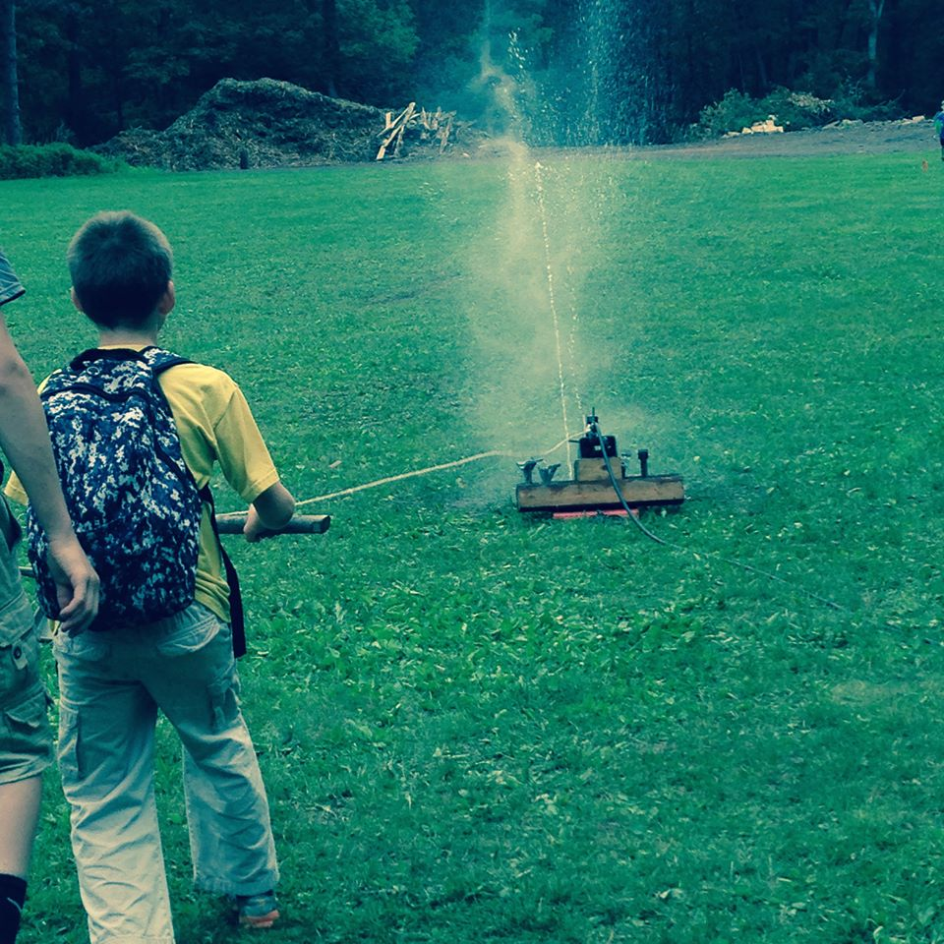
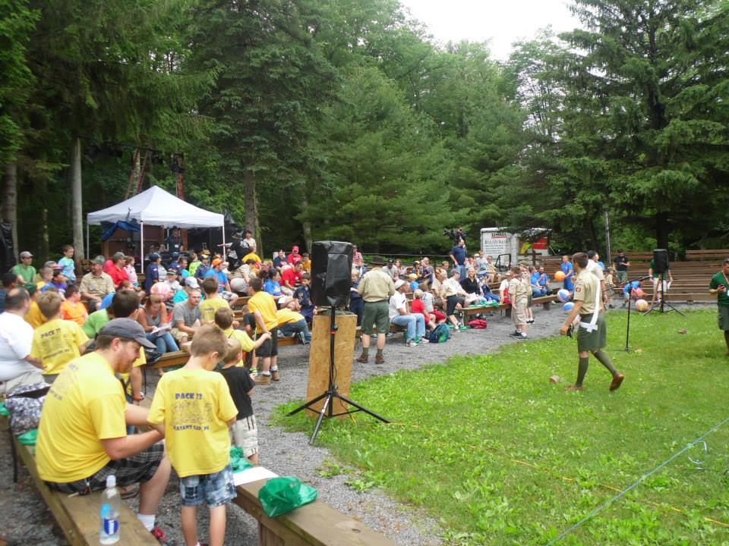
Cubclave opening show (above) and Cubclave water bottle rockets (right)
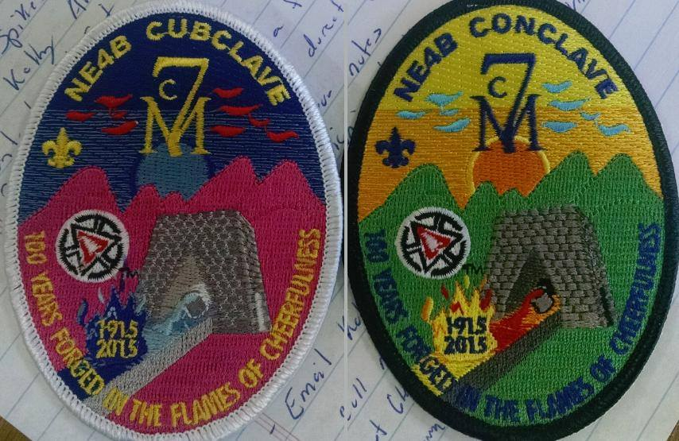
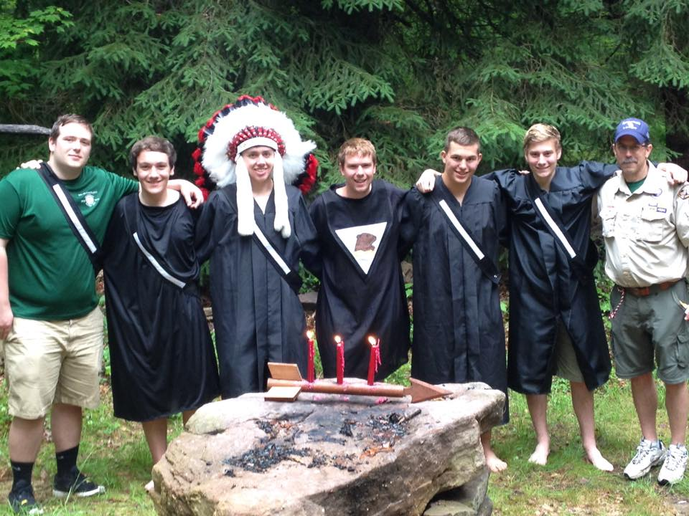
The “original” Ordeal Ceremony ceremonies team poses with Monaken Lodge Advisor

